**Mini Project Report**

**on**

**Society Sync: Connecting residents**

**for better living**

Submitted in partial fulfillment of the requirements for the degree

**Second Year Engineering – Computer Science and Engineering Data Science**

by

**Soham Dewrukhkar 22107054**

**Varad Chaudhari 22107053**

**Sahil Gorde 22107035**

**Ayush Maurya 22107029**

**Under the guidance of**

**Prof.Sarala Mary**

**DEPARTMENT OF COMPUTER SCIENCE AND ENGINEERING DATA SCIENCE**

A.P. SHAH INSTITUTE OF TECHNOLOGY

G.B. Road, Kasarvadavali, Thane (W)-400615

UNIVERSITY OF MUMBAI

**Academic year: 2023-24**

**CERTIFICATE**

This to certify that the Mini Project report on Society Sync: Connecting Residents for better living has been submitted by Soham Dewrukhkar(22107054), Varad Chaudhari (22107053) ,Sahil Gorde(22107035) and Ayush Maurya(22107029) who are bonafide students of A. P. Shah Institute of Technology, Thane as a partial fulfillment of the requirement for the degree in **Computer Science and Engineering Data Science**, during the academic year **2023-2024** in a satisfactory manner as per the curriculum laid down by the University of Mumbai.

**Prof.Sarala Mary**

**Guide**

**Prof. Anagha Aher Dr. Uttam D. Kolekar**

**HOD, CSE Data Science Principal**

**External Examiner:**

1.

**Internal Examiner:**

1.

**Place:** A. P. Shah Institute of Technology, Thane

**Date:**

**ACKNOWLEDGEMENT**

This project would not have come to fruition without the invaluable help of our guide **Prof.Sarala Mary**. Expressing gratitude towards our HoD, **Prof. Anagha Aher**, and the Department of CSE Data Science for providing us with the opportunity as well as the support required to pursue this project. We would also like to thank our project coordinators Prof. Vaibhav S. Yavalkar and Prof. Avani Nair who gave us valuable suggestions and ideas when we needed them. We would also like to thank our peers for their helpful suggestions.

**TABLE OF CONTENTS**

Abstract

1. Introduction………………………………………………………………………..1
   1. Purpose.............................................................................................................2
   2. Problem Statement…………………………………………………………...2
   3. Objectives........................................................................................................2
   4. Scope.........................................................................................................…...3
2. Literature Review……………………………………………………………….....4
3. Proposed System………..........................................................................................5
   1. Features and Functionality…………………………………………………..5
4. Requirements Analysis.............................................................................................7
5. Project Design..........................................................................................................8
   1. System Architecture …………………………………………………………8
   2. Implementation …………….………………………………………………..10
6. Technical Specification……………...………………………………………….....17
7. Project Scheduling...................................................................................................18
8. Results……………..………………………………………………………………24
9. Conclusion…………………....................................................................................25
10. Future Scope……………………………………………………………………….26

Reference………………………………………………………………………………27

**Chapter 1**

**Introduction**

In contemporary urban landscapes, Society Sync: Connecting Residents for Better Living plays a pivotal role in providing affordable and community-centric housing solutions. However, the management of these societies often poses significant challenges, ranging from cumbersome administrative tasks to communication inefficiencies among members. Consequently, there arises a pressing need for streamlined solutions that enhance operational efficiency while fostering transparent communication and effective governance within these communities.

This report delves into the development and implementation of Society Sync, a platform leveraging the Python Django framework. This work aims to address the prior challenges by providing a comprehensive solution that simplifies administrative tasks, facilitates seamless communication, and promotes effective oversight by both administrators and residents.

The scope of this report encompasses the design, development, and deployment of Society Sync, along with an in-depth exploration of its features and functionalities. Additionally, it delves into the underlying technologies and methodologies employed in the development process, elucidating the rationale behind key design decisions and implementation strategies.

Significant contributions from this investigation include the creation of a user-friendly interface that caters to the diverse needs of housing society administrators and residents. Moreover, the platform's robust set of features not only streamlines administrative operations but also promotes transparency and accountability within the community. By presenting a detailed analysis of the platform's design and functionality, this report aims to provide valuable insights for stakeholders involved in community management, ultimately contributing to more efficient and harmonious community living.

**1.1 Purpose :**

The purpose of developing Society Sync: Connecting Residents for Better Living is multifaceted. Firstly, the platform aims to streamline the management processes of housing societies, addressing the challenges associated with administrative tasks, communication gaps, and governance inefficiencies.

Society Sync aims to enhance operational efficiency and transparency within communities by providing a user-friendly interface and a robust set of features. Furthermore, the platform seeks to foster a sense of community and belonging among residents by facilitating seamless communication and collaboration.

By enabling residents to connect with each other, share information, and participate in community activities, Society Sync aims to create a vibrant and harmonious living environment. Moreover, Society Sync serves as a tool for promoting accountability and transparency within housing societies.

By providing transparent access to important information, such as financial records, meeting minutes, and maintenance schedules, the platform empowers residents to actively participate in decision-making processes and hold administrators accountable for their actions.

Overall, the purpose of Society Sync is to improve the quality of life for residents within housing societies by enhancing communication, efficiency, and community engagement. Through its innovative features and functionalities, the platform aims to create a more connected and vibrant living environment for all residents.

**1.2 Problem Statement:**

In housing societies, there exists a significant challenge in effectively managing administrative tasks, fostering communication among residents, and promoting transparency and accountability within the community. Manual processes often lead to inefficiencies, while communication gaps hinder community engagement and decision-making. Furthermore, the lack of transparent access to important information can result in trust and satisfaction among residents. Thus, there is a pressing need for a comprehensive solution that addresses these challenges by streamlining management processes, enhancing communication, and promoting transparency and accountability within housing societies.

**1.3 Objectives :**

**Objectives:**

The objectives of our project underscore our commitment to delivering a top-tier society administrative application that caters to the needs and aspirations of housing societies. Let's delve deeper into each of these key objectives:

1. Simplify Administrative Tasks:

Develop features within Society Sync to automate and streamline administrative processes such as member management, billing, and maintenance requests to reduce manual workload and enhance efficiency.

2. Enhance Communication:

Implement communication tools within Society Sync to facilitate seamless interaction among residents, enabling them to share information, collaborate on community initiatives, and stay informed about important announcements and events.

3. Foster Community Engagement:

Create features within Society Sync to promote resident engagement and participation in community activities, such as organizing events, forming interest groups, and sharing resources, to strengthen social bonds and create a sense of belonging.

4. Promote Transparency and Accountability:

Incorporate transparency measures within Society Sync to provide residents with access to relevant information, such as financial records, meeting minutes, and decision-making processes, to foster trust and accountability within the community.

5. Improve Operational Efficiency:

Optimize Society Sync to enhance operational efficiency by providing administrators with tools for data analysis, reporting, and task management, enabling them to make informed decisions and allocate resources effectively.

**1.4 Scope:**

This project can be enhanced further by adding an online gig-booking facility for the members to reduce the extra work of the admin. The software is flexible enough to be modified and implemented as per future requirements. We have tried our best to present this free and user–friendly website to Society members. Message and Email alerts for various happenings in the society can be added to the system so that users do not miss the updates and happenings of the society.

**Chapter 2**

**Literature Review**

In their 2022 study, Mayank Thacker, Lay Shah, and Manan Shah focused on the digitalization of society management systems using artificial intelligence technologies. Their research delved into two key areas: web development and artificial intelligence. The study emphasized the benefits of enhanced transparency through real-time updates and notifications, which enable residents to stay informed about important developments in their societies. Additionally, the implementation of digital systems provided convenience for residents to report issues, make payments, and communicate with management seamlessly. However, the researchers also highlighted adoption challenges faced by older residents who may not be as tech-savvy, indicating a need for user-friendly interfaces and training programs to bridge this gap[1].

In her 2023 study, Likhitha Reddy Eddala focused on developing a web-based management system specifically designed for housing societies, complemented by an Android application. The research primarily addressed the need for streamlined communication between residents and management, aiming to improve overall efficiency and resident satisfaction. Additionally, the system aimed to facilitate the efficient management of essential resources such as water, electricity, and maintenance tasks, enhancing sustainability and cost-effectiveness for housing societies. However, a key challenge highlighted in the study was the system's dependence on reliable internet connectivity for effective operation, suggesting the importance of robust infrastructure and backup measures to ensure uninterrupted service delivery[2].

In his 2018 study, Tirth Shah explored the development of a cloud-based Housing Society Management System, focusing on web development and cloud computing technologies. The study emphasized the implementation of automated task allocation and scheduling to streamline maintenance and repair processes within housing societies, aiming to improve operational efficiency and resident satisfaction. However, the research also identified privacy concerns related to data collection and management within cloud-based systems, highlighting the importance of robust data protection measures and transparent privacy policies to address these issues effectively[3].

**Chapter 3**

**Proposed System**

The proposed system, Society Sync: Connecting Residents for Better Living, is a comprehensive platform designed to address the challenges associated with managing cooperative housing societies. By leveraging advanced technologies and innovative features, Society Sync aims to streamline administrative tasks, enhance communication, foster community engagement, and promote transparency and accountability within housing societies.

**3.1 Features and Functionality**

1. Member Management: Society Sync will provide administrators with tools to efficiently manage member records, including personal information, contact details, and membership status. This feature will streamline the process of adding new members, updating existing records, and maintaining an accurate database of society residents.

2. Billing and Payment: The platform will automate billing processes for maintenance fees, utilities, and other expenses. Residents will receive invoices electronically, and reminders for overdue payments will be sent automatically, reducing administrative overhead and ensuring timely payments.

3. Complaint Registration: Society Sync will include a dedicated module for residents to register complaints regarding maintenance issues, community concerns, or any other grievances. Residents will be able to submit details of their complaints, including descriptions, and categories through the platform. Administrators will be able to track and manage them efficiently. This feature will streamline the complaint resolution process, ensuring timely responses and improved resident satisfaction.

4. Visitor Log: Society Sync will introduce a visitor log feature to record and manage visitor entries within the housing society. Residents will be able to register their visitors through the platform, providing details such as visitor names, contact information, and purpose of visit. Additionally, residents may receive notifications upon the arrival and departure of their registered visitors. This feature will enhance security measures and enable better visitor management within the housing society.

In summary, the proposed system, Society Sync, aims to revolutionize cooperative housing society management by providing a comprehensive solution that addresses the diverse needs of residents and administrators. By streamlining administrative tasks, enhancing communication, fostering community engagement, and promoting transparency and accountability, Society Sync will empower housing societies to thrive and prosper in the digital age.

**Chapter 4**

**Requirement Analysis**

The success of the Society Sync: Connecting Residents for better living project hinges on its software requirements, which play a pivotal role in ensuring seamless functionality and a user-friendly experience. Let's delve into the software requirements for this visionary initiative based on the software stack. The project's software should be compatible with various operating systems to ensure accessibility for a broad range of users. It's crucial to develop a platform that runs smoothly on different operating systems, accommodating both housing society residents and administrators. The web app's frontend should be designed using HTML, CSS,Django and Python 3.9 to create a modern, responsive, and interactive user interface. Python 3.9 offers a wide range of libraries and tools for web development, while HTML and CSS provide the structure and styling necessary for an intuitive user experience. The development ensures compatibility with MySQL for efficient database management, facilitating seamless data storage and retrieval. In the context of the Society Sync: Connecting Residents for better living project, the software stack serves as the backbone for realizing the project's vision. Here's how these software requirements contribute to the project's success:

Compatibility: Ensuring compatibility with various operating systems broadens the user base, enabling housing society residents and administrators to access the platform regardless of their operating system.

User-Friendly Frontend: HTML, CSS,Django and Python 3.9 contribute to an intuitive and visually appealing frontend. A clean and responsive design is essential for providing a positive user experience.

Development Efficiency: Python 3.9 simplifies the development process, allowing the development team to write, debug, and manage code effectively, thereby improving overall development efficiency.

MySQL Backend: MySQL ensures efficient data storage and retrieval, facilitating seamless backend database management for the Society Sync platform."

**Chapter 5**

**Project Design**

**5.1 System Architecture**

Managing a society smoothly often requires efficient communication and streamlined processes. A society management system can be a valuable tool to bridge this gap. These systems offer functionalities for both residents and administrators, fostering a more connected and organized community.According to Fig 5.1.1

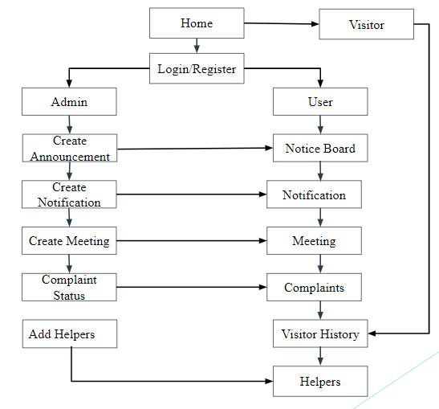

Fig:5.1.1 System Design

It has functionalities for both administrators and users. Here’s a breakdown of the functionalities based on the system architecture:

Admin

* Create Announcement: This allows the creation of announcements likely to be displayed on a notice board.
* Create Notification: This allows the creation of notifications likely to be sent to users.
* Complaint Status: This allows admins to view the status of complaints.
* Add Helpers: This allows admins to add helpers, potentially for managing the society.

User

* Notice Board: This section displays announcements created by the admin.
* Meeting: This section allows users to view meetings.
* Complaint: This section allows users to submit complaints.
* Visitor History: This section allows users to view the visitor history.

**5.2 Implementation**

Admin Panel:

1. Dashboard

- Admin can delete the user and authenticate and check if their information is correct and can navigate to all other features available to admin. Fig 5.2.1.

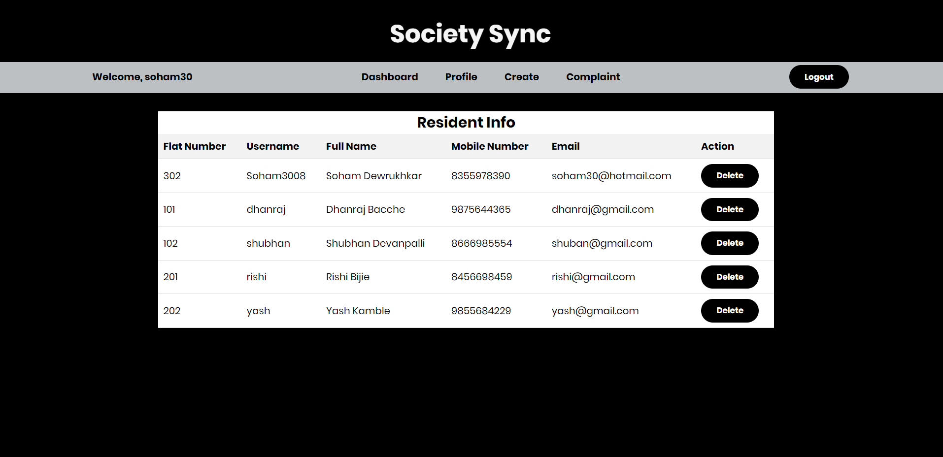

Fig:5.2.1 Admin Dashboard

2. Announcement and Notification:

- Admin can create announcements and notifications which will be further displayed on the user side. Announcements will be displayed in the notice board section and notifications will be displayed in the notification box. As shown in Fig 5.2.2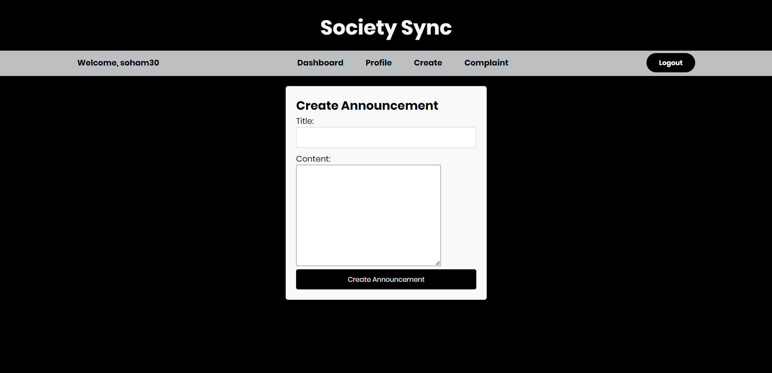

Fig:5.2.2 Create Announcement/Notification

3. Meeting:

- Admin can create virtual meetings and can share the code with the society members with the help of a notification box. As shown in Fig 5.2.3

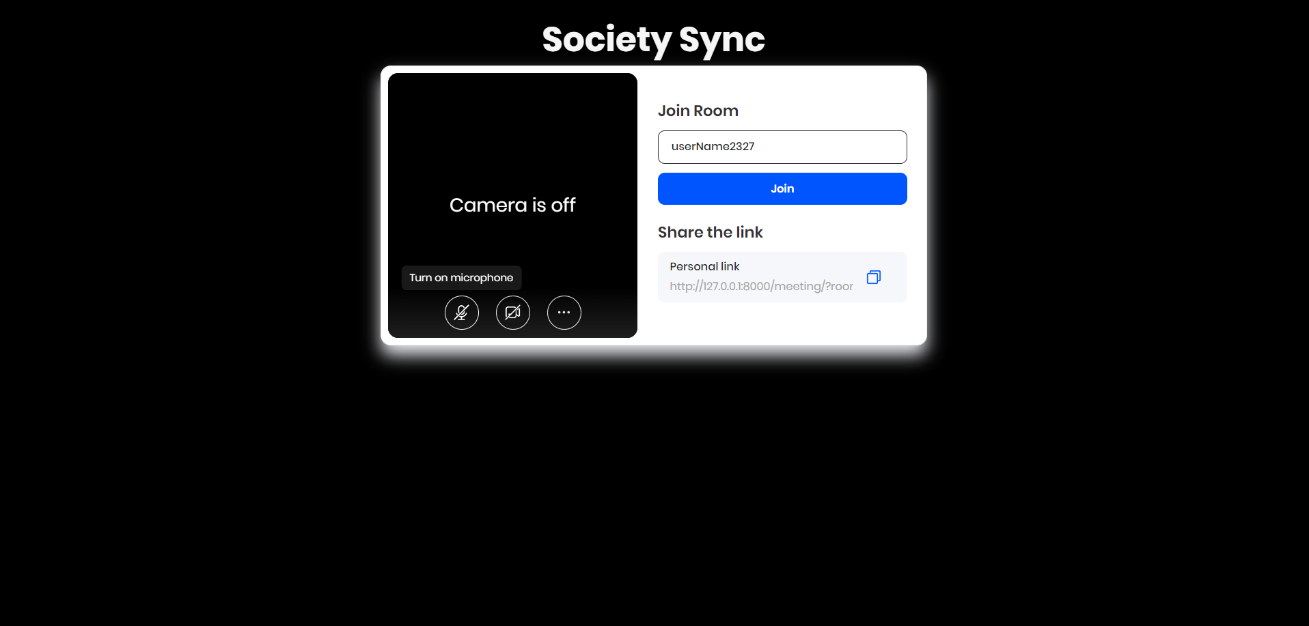

Fig:5.2.3 Meeting

4. Complaint:

- Admin can mark ongoing complaints as completed once the complaint shown in Fig 5.2.4 is resolved and also can view all the complaints registered by all the users.

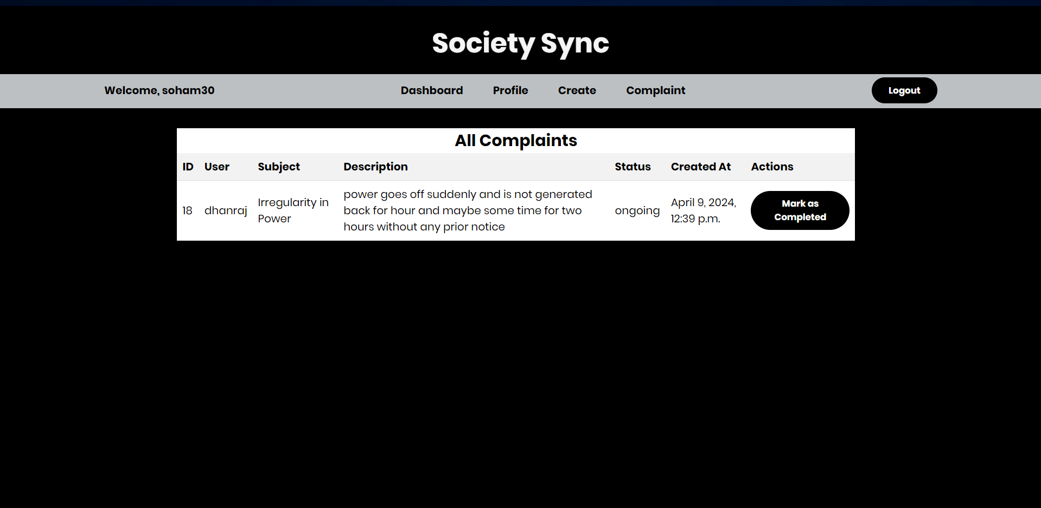

Fig:5.2.4 Complaint Status

User Panel:

1. Dashboard:

- The user interface as shown below in Fig 5.2.6 is simply a society management system for even elderly people and simply the GUI and features for them.

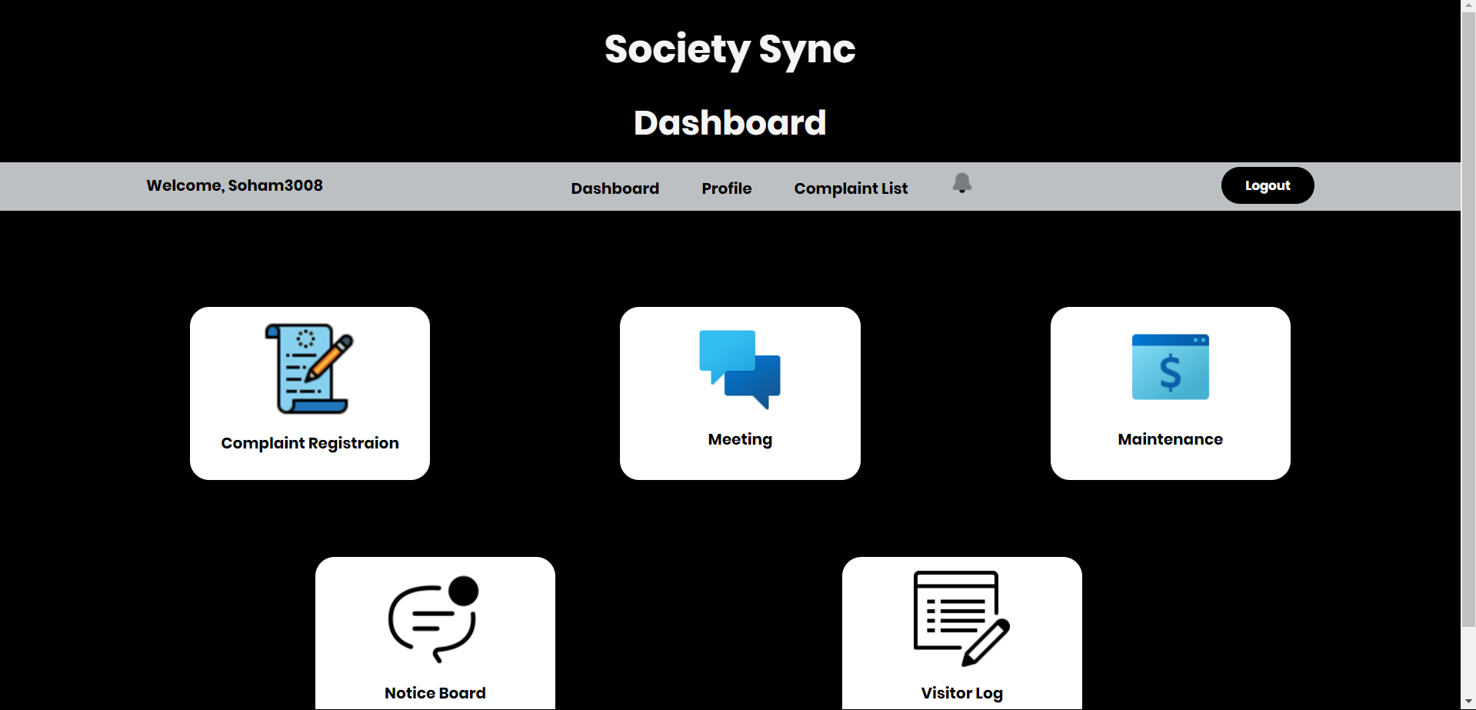

Fig:5.2.6 User Dashboard

2. Complaint Registration:

- User can register their complaints related to any incident or any irregularities regarding the working of the society. As shown in Fig 5.2.7

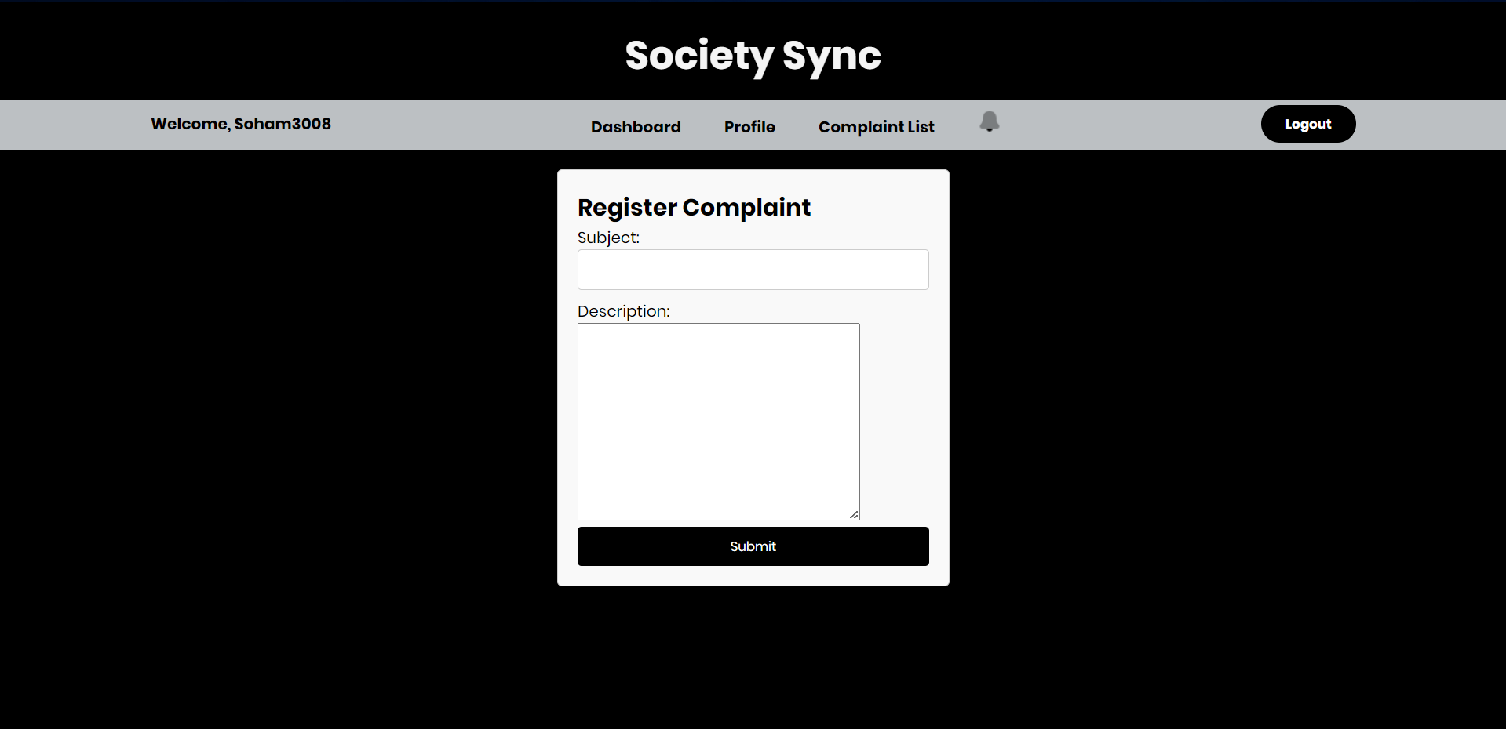

Fig:5.2.7 Complaint Registration

3. Maintenance Bill:

- User can pay their maintenance bill using our application which is generated once in a month, we have integrated Razorpay integration using its API keys. As shown in Fig 5.2.9

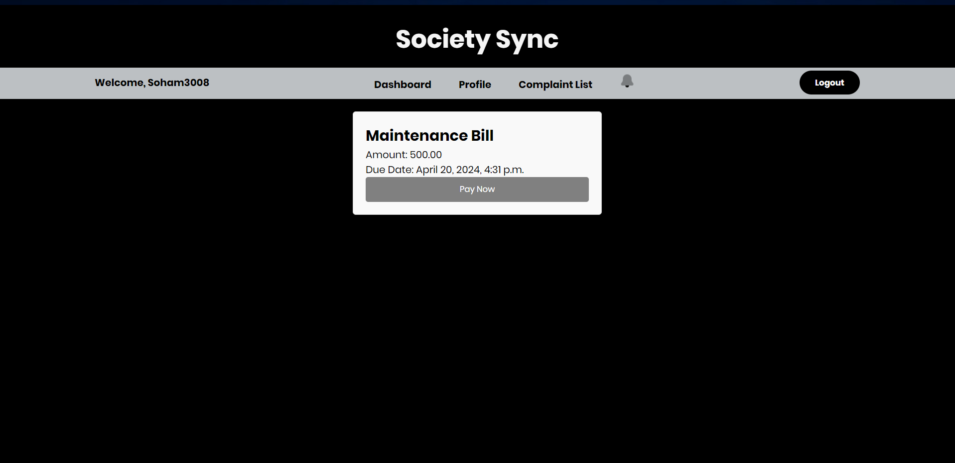

Fig:5.2.8 Maintence Bill

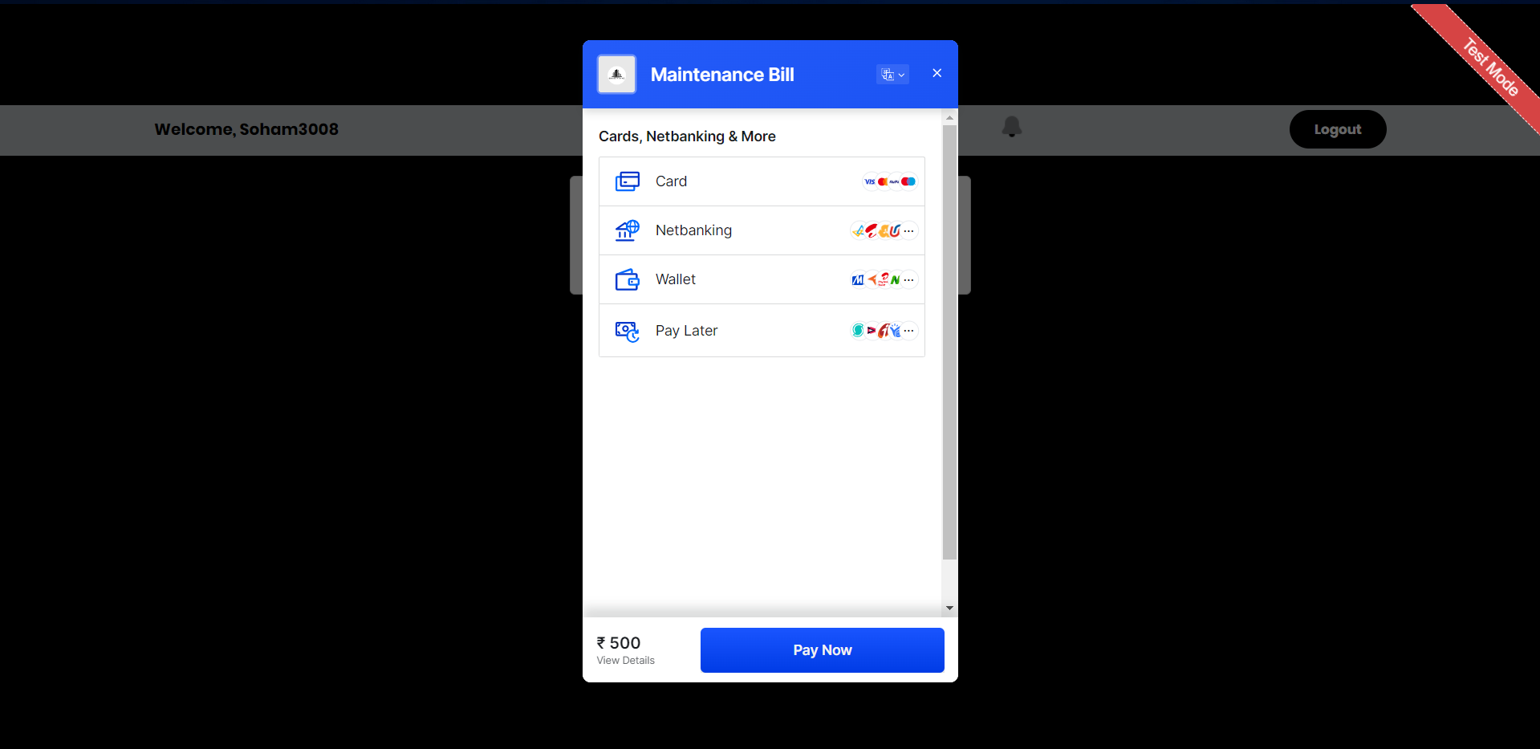

Fig 5.2.9 Payment Mode

4. Notice Board and Visitor Log:

- Users can view all the announcements made by admins on the notice board page. As shown Fig 5.2.10 and in the visitor log section users can view all the visitors who visited them. As shown Fig 5.2.11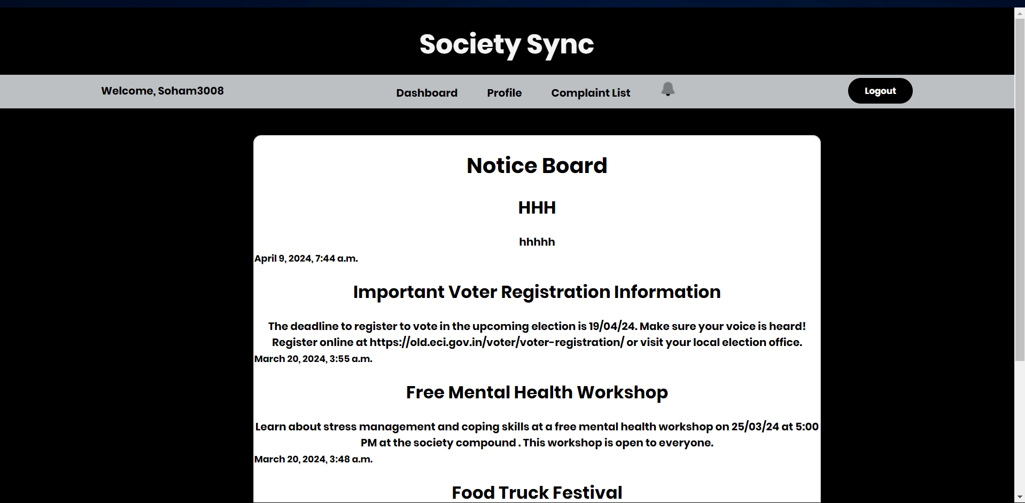

Fig 5.2.10 Notice Board

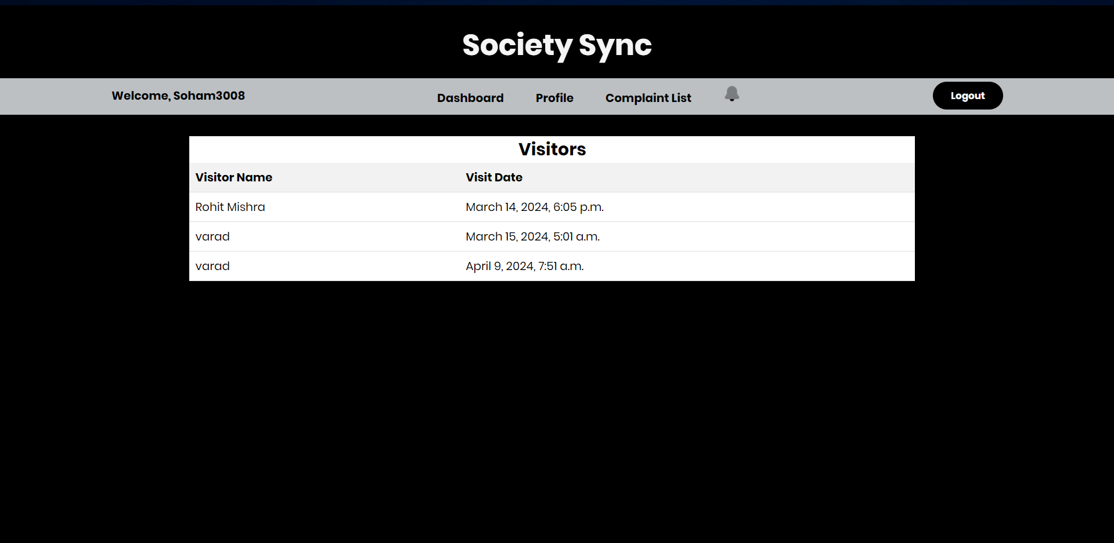

Fig:5.2.11 Visitor Log

**Chapter 6**

**Technical Specification**

Frontend:

1. HTML, CSS, JavaScript (JS):

Utilize HTML for structuring web pages.

CSS for styling and layout.

JavaScript for dynamic and interactive functionalities.

Frameworks/libraries like Bootstrap or Materialize for responsive design and UI components.

Backend:

1. Django Framework:

Django for rapid development, following the Model-View-Template (MVT) architecture. Use Django's built-in features like authentication, URL routing, and templating for efficient backend development.

2. Python:

Python for backend logic, implementing business rules, and handling data processing. Utilize Django's ORM (Object-Relational Mapping) for database operations to abstract away SQL queries.

Database:

1. MySQL:

MySQL is the relational database management system (RDBMS) for storing structured data. Define database schemas for entities like users, events, facilities, complaints, etc., using Django models.

**Chapter 7**

**Project Scheduling**

The table outlines is as shown in Table 7.1 for project timeline and task allocation for a group comprising Soham Dewrukhkar, Sahil Gorde, Varad Chaudari, and Aayush Maurya. The project appears to be focused on developing an application or system, with various stages from topic selection to final presentation and report writing.

|  |  |  |  |
| --- | --- | --- | --- |
| Sr.  No | Group Member | Time duration | Work to be done |
| 1 | Soham Dewrukhkar  Sahil Gorde  Varad Chaudari  Aayush Maurya | 2nd week of  January | Topic selection. |
| 3rd week of  January | Making paper proto-type for selected topic. |
| 2 | Soham Dewrukhkar  Sahil Gorde  Varad Chaudari  Aayush Maurya | 4th week of January | Discussed features of applications. |
| 1st week of February | Searched literature review paper. |
| 3 | Soham Dewrukhkar  Sahil Gorde  Varad Chaudari  Aayush Maurya | 2nd week of February | Study of the literature  Paper. |
| 3rd week of February | Designing the Graphical User Interface (GUI) |
| 4 | Soham Dewrukhkar  Sahil Gorde  Varad Chaudari  Aayush Maurya | 4th week of February | Designing the Graphical User Interface (GUI) |
| 5 | Soham Dewrukhkar  Sahil Gorde  Varad Chaudari  Aayush Maurya | 2nd week of March | Presentation I |
| 6 | Soham Dewrukhkar  Sahil Gorde  Varad Chaudari  Aayush Maurya | 3rd week of March | Database Connectivity  of all modules |
| **7** | Soham Dewrukhkar  Sahil Gorde  Varad Chaudari  Aayush Maurya | 4th week of March | Integration of all modules and Report Writing |
| 8 | Soham Dewrukhkar  Sahil Gorde  Varad Chaudari  Aayush Maurya | 1st week of April | Presentation II |

Table:7.1 Project Scheduling

In the first row, the timeline is divided into weeks, starting from the second week of January and extending to the first week of April. Each row corresponds to a specific task or milestone within this timeline, with the responsible group members listed alongside.

The tasks include:

1. Topic selection: In the third week of January, the group decides on the topic for their project.

2. Paper prototype: By the third week of January, the group creates a paper prototype for the selected topic, outlining the basic design and functionality.

3. Feature discussion: In the fourth week of January and the first week of February, the group discusses the features of the application they plan to develop.

4. Literature review: During the first and second weeks of February, the group conducts a literature review to gather relevant information and insights.

5. Study of literature paper: In the second week of February, the group studies the literature papers they've gathered to inform their project.

6. GUI Design: By the third and fourth weeks of February, the group designs the graphical user interface (GUI) for their application.

7. Presentation I: In the second week of March, the group makes their first presentation, presumably to showcase their progress and plans.

8. Database connectivity: During the third week of March, the group focuses on implementing database connectivity for all modules of their application.

9. Integration and report writing: By the fourth week of March, the group will integrate all modules of their application and begin writing their project report.

10. Presentation II: Finally, in the first week of April, the group delivers their second presentation, likely to present their completed project and findings.

Overall, the table provides a clear breakdown of tasks, timelines, and responsibilities for each stage of the project, guiding the group through the development process from inception to completion

**Gantt Chart**

A Gantt chart is a helpful tool as shown in Fig7.1 for visually representing project schedules. It shows task durations, start and finish dates, and task relationships, aiding in project management and progress tracking.

The Society Sync project aims to modernize operations, enhancing efficiency and user experience, with further potential for tech integration. This focus on improving operations, maintenance management, and user experience reflects its commitment to delivering a comprehensive rental solution.

The chart's rows contain task titles like project conception and design, with subdivisions. Columns show task durations, work completion percentages, weeks needed, specific dates, and team members.

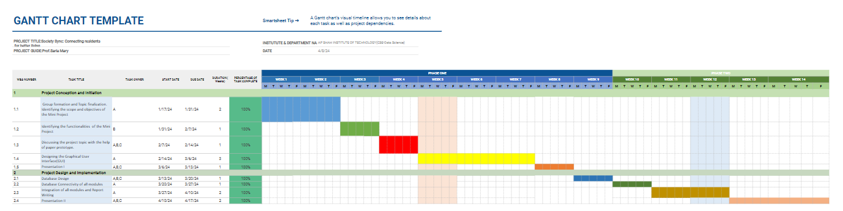

Fig7.1 Gantt Chart

The Gantt chart for the rental sports hub project begins with the project conception and initiation phase, starting on 17/01/24 and lasting for two weeks. During this time, the team will form and finalize the project's focus, involving Aayush, Sahil, Soham, and Varad. Following this, the scope and objectives of the mini-project will be identified from 31/01/24 to 07/02/24, with Sahil and Soham leading this task. The team will then discuss the project topic using a paper prototype from 07/02/24 to 21/02/24, with input from all members. Designing the Graphical User Interface (GUI) will be the next major task from 21/02/24 to 06/03/24, led by Sahil and Soham.

The project progressed with Presentation I scheduled for 06/03/24 to 19/03/24, requiring preparation from all team members. Project design and implementation will take place from 19/03/24 to 27/03/24, involving all team members. Database design follows from 27/03/24 to 03/04/24, with contributions from all members. Database connectivity of all modules will be addressed by Sahil and Varad from 03/04/24 to 10/04/24. Integration of all modules and report writing is scheduled for 10/04/24 to 24/04/24, involving Soham, Aayush, and Varad. Lastly, Presentation II is set for 10/04/24 to 17/04/24, with all team members contributing to its preparation.

**Chapter 8**

**Result**

The successful implementation of the Society Sync: Connecting Residents for Better Living project marks a significant milestone in the realm of cooperative housing society management. Through meticulous planning, diligent execution, and unwavering dedication, our team has crafted a revolutionary platform that transcends conventional boundaries. At its core, Society Sync represents a paradigm shift in how housing societies are managed, offering a holistic solution that addresses the diverse needs and challenges faced by residents and administrators alike.

The result of our endeavors is not merely a software application, but a transformative tool that redefines the dynamics of community living. By placing users at the forefront of our design philosophy, we have created a platform that is intuitive, accessible, and immensely empowering. Residents now have access to a suite of communication tools, including visitor logs and announcement boards, facilitating seamless interaction and information sharing within the community. This newfound connectivity not only enhances the overall sense of belonging but also fosters a culture of collaboration and mutual support.

In essence, Society Sync represents more than just a software solution—it embodies a vision of community empowerment, collaboration, and progress. As we look towards the future, we remain steadfast in our commitment to innovation and excellence, continuously striving to enhance the quality of life for residents and administrators alike. With Society Sync, the journey towards better living has only just begun.

**Chapter 9**

**Conclusion**

Hence, the development and implementation of Society Sync: Connecting Residents for better living, a web-based application, provides a seamless user experience for residents and administrators alike. Overall, Society Sync emerges as a valuable tool for housing society members seeking efficient management and enhanced community engagement. The platform's features, user-friendly interface, and comprehensive functionalities make it a top choice for those involved in cooperative housing society management. Through meticulous development and implementation efforts, Society Sync delivers streamlined administrative processes, transparent communication channels, and robust community engagement tools. With its intuitive design and efficient functionality, Society Sync empowers residents to stay informed, connected, and actively involved in shaping their living environment.

**Chapter 10**

**Future Scope**

The future scope of society management systems is vast, encompassing advancements in technology, community engagement, sustainability, and data-driven decision-making.

**Smart Infrastructure Integration**: Implementing Internet of Things (IoT) devices for real-time monitoring and management of community resources such as energy consumption, water usage, waste management, and security systems. This can lead to improved efficiency, cost savings, and sustainability.

**Continuous Improvement and Feedback Mechanisms:** Establishing feedback loops, community surveys, satisfaction assessments, and improvement initiatives based on member feedback. This fosters continuous improvement, transparency, and community-driven decision-making

**Scalability and Flexibility:** Designing the society sync framework to be scalable and adaptable to accommodate growth, evolving requirements, technological advancements, and changing community dynamics over time.

**Event Management:** Facilitate the management of events, meetings, and activities within the society. This includes features for event scheduling, RSVP management, event promotion, ticketing or registration, and post-event feedback collection.

**Security and Privacy**: Implement robust security measures to protect sensitive data, ensure data privacy, prevent unauthorized access, and comply with data protection regulations. This includes encryption, authentication, data backups, and security audits.

**Communication Channels:** Provide multiple communication channels for residents, committee members, management, and service providers. This includes email, SMS alerts, in-app notifications, discussion forums, and announcements to keep stakeholders informed and engaged.

**References**

[1] Gupta, M., & Jain, S. (2017). "Society Management System: A Comprehensive Approach." International Journal of Computer Applications, 159(11),

[2]Goyal, P., & Joshi, N. (2018). "Smart Society Management System with Mobile Application Integration." International Journal of Advanced Research in Computer Science, 9(1), 195-199.

[3]Giannetsos Athanasios, “Intrusion Detection in Wireless Sensor Networks”, Master THESIS, Carnegie Mellon University, April 8, 2008.

[4]Kulkarni, A., & Deshpande, S. (2016). "Cloud-Based Society Management System: An Overview." International Journal of Computer Applications, 140(9), 12-15.

[5]Maharashtra Co-operative Housing Societies Act; [MCS Act] 1960.